SUNBUST ALL MOPAR SHOW/SHINE & SWAP MEET
Presented by Mopars Unlimited Tacoma Chapter

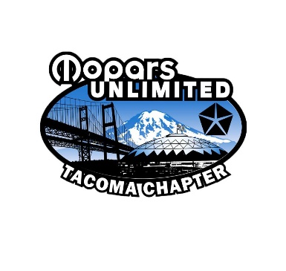
The Mopars Unlimited – Tacoma Chapter is a nonprofit organization. Our goal is to promote the community by providing scholarships to local colleges and offering donations to local charities. In 2018, we donated over $2,500.00. On Sunday, August 16th, we are holding our 35th annual Sunbust Car Show and Swap Meet at the Pierce County Fairgrounds (Frontier Park) in Graham, WA. Last year we handed out 5,000 show fliers across the Northwest. This year, we expect over 300 cars to register, 25 vendors, up to 50 swap meet vendors, and up to 3,000 spectators to attend from across the Northwest. It would be greatly appreciated if you could sponsor our car show or make a donation to our raffle or goodie bags. Your business name will be verbally promoted as well as prominently marked on items on display. We also continue to encourage our members to patronize your business, and a link to your webpage will be placed on our webpage.
www.moparsunlimited.org or visit our Facebook page - Mopars Unlimited - Tacoma
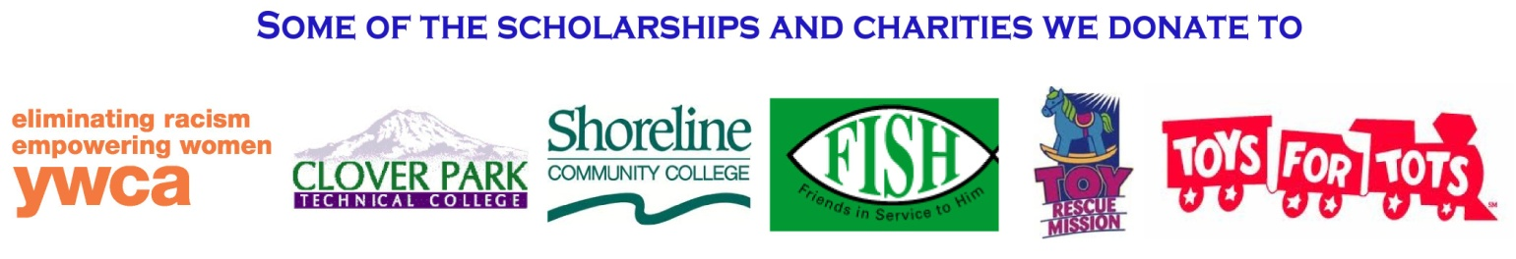
Mopars Unlimited-Tacoma Chapter
P.O. Box 44903
Tacoma, WA 98445

What Mopars Unlimited can do for your sponsorship of Sunbust

Level 1 - Donate items to our Raffle
We will note your business on the raffle items and mention your business
when the raffle item is called upon.
Level 2 - Sponsorship of $50-$249 (Cash sponsorship only)
All fliers will have your business name and phone number listed (3,000 to 5,000 fliers)
Your business logo and a link to your web page will be placed on our web-page.
Level 3 - Sponsorship of $250-499 (Cash sponsorship only)
Your business will appear on the 2018 Sunbust show shirts.
All fliers will have your business name and phone number listed (3,000 to 5,000 fliers).
Your business logo and a link to your web page will be placed on our web-page.
Level 4 - Sponsorship greater than $500 (Cash sponsorship only)
Your business will appear on all trophies awarded (42 classes with 3 awards per class).
We will advertise your business throughout the day of the show.
You will be given a vendor space to promote your business. Your business will appear on the 2018 Sunbust show shirts.
All fliers will have your business name and phone number listed (3,000 to 5,000 fliers).
Your business logo and a link to your web page will be placed on our web-page.

